

SUPERVISOR’S RECOMMENDATION
I hereby recommend that this report has been prepared under my supervision by Anish Ghimire (TU Exam Roll No: 26350/077), Bipesh Adhikari (TU Exam Roll No: 26356/077), Jagrit Prasad Upadhyay Dahal (TU Exam Roll No: 26365/077). I am pleased to endorse the submission of a report titled “Chat Forum using Skipgram for Query Analysis” which has been authored under guidance by Mr. Hemanta Mehta as part of the requirements for the Bachelor of Science degree in Computer Science and Information Technology (BSc.CSIT). The content of their report meets the necessary standards and is recommended for further evaluation.

------------------------------------
Hemanta Mehta
Full Time Faculty
Orchid International College
Bijaychowk, Gaushala

CERTIFICATE OF APPROVAL
This certifies that the project " Chat Forum using Skipgram for Query Analysis " completed by Anish Ghimire (TU Exam Roll No: 26350/077), Bipesh Adhikari (TU Exam Roll No: 26356/077), Jagrit Prasad Upadhyay Dahal (TU Exam Roll No: 26365/077), partially fulfills the requirements for the degree of B. Sc. in Computer Science and Information Technology. We believe it to be a suitable project for the desired degree in terms of both scope and quality.

…………………………  Hemanta Mehta  Supervisor,  Orchid International College  Bijyachowk, Gaushala | …………………………  Er. Dhiraj Kumar Jha  Head of Department,  Orchid International College  Bijyachowk, Gaushala
……………………
External Examiner
Central Department of Computer Science and IT, Tribhuvan University
Kritipur, Nepal

ACKNOWLEDGEMENTS
We would like to express our heartfelt gratitude to everyone who supported and guided us throughout the development of this project. First and foremost, we would like to thank, Orchid International College for providing us with the opportunity and resources to undertake this project. We are deeply grateful to our project coordinator, Er. Dhiraj Kumar Jha, for his continuous guidance, encouragement, and valuable feedback, which helped us stay on track and improve our work.
We extend our sincere thanks to our supervisor Mr. Hemanta Mehta, for his expert advice, constructive criticism, and unwavering support. His insights and mentorship were crucial in overcoming challenges and completing this project successfully. This project is a testament to the collaborative spirit fostered by Orchid International College, and we are truly appreciative of the knowledge and skills gained during our academic journey.

Anish Ghimire [TU Roll Number: 26350/077]
Bipesh Adhikari [TU Roll Number: 26356/077]
Jagrit Prasad Upadhyay Dahal [TU Roll Number: 26365/077]

ABSTRACT
A chat forum allows users to engage in discussions, share information, and collaborate in real-time. This project focuses on building a chat forum system with features like user authentication, thread creation, message exchange and many more. The system ensures secure and organized conversations by implementing user authentication and real-time message synchronization. The backend is developed using Django, while the frontend leverages Next.js and Tailwind CSS for a user-friendly interface. The project followed an incremental and iterative software development methodology, allowing continuous improvements throughout the development process. For machine learning, dataset was collected from Kaggle, and the Skipgram algorithm with negative sampling was used to analyse user search queries and find related threads. The project provides an efficient and interactive communication platform, supporting online communities, educational discussions, and professional collaboration.

Keywords: Chat Forum, Real-Time Communication, User Authentication, Thread Management, Machine Learning, Skipgram Algorithm, Negative Sampling, Message Synchronization, Online Community, Django, Professional Collaboration.

TABLE OF CONTENTS
SUPERVISOR’S RECOMMENDATION i
CERTIFICATE OF APPROVAL ii
ACKNOWLEDGEMENTS iii
ABSTRACT iv
LIST OF FIGURES vii
LIST OF TABLES ix
LIST OF ABBREVIATIONS x
CHAPTER 1- INTRODUCTION 1
1.1 Introduction 1
1.2 Problem Statement 1
1.3 Objectives 2
1.4 Scope and Limitation 2
1.5 Development Methodology 3
1.6 Report Organization 4
CHAPTER 2- BACKGROUND STUDY AND LITERATURE REVIEW 6
2.1 Background Study 6
2.2 Literature Review 6
CHAPTER 3- SYSTEM ANALYSIS 8
3.1 System Analysis 8
3.1.1 Requirement Analysis 8
3.1.2 Feasibility Analysis 10
3.1.3 Analysis 12
CHAPTER 4- SYSTEM DESIGN 16
4.1 Design 16
4.1.1 Refined Class Diagram 18
4.1.2 Refined Sequence Diagram 20
4.1.3 Component Diagram: 21
4.1.4 Deployment Diagram: 22
4.2 Algorithm Details 22
4.2.1 Skipgram Model with Negative Sampling: 23
4.2.2 Loss Function and Training Objective 23
4.2.3 Model Inference 25
CHAPTER 5- IMPLEMENTATION AND TESTING 26
5.1 Implementation 26
5.1.1 Tools Used 26
5.1.2 Implementation Details Of Modules 26
5.1.3 Implementation Details Of the Algorithm 29
5.2 Testing 36
5.2.1 Test Case for Login Testing 36
5.2.2 Test Case for Message Exchange Testing 37
5.2.2 Real-Time Test Scenario 38
5.3 Result Analysis 42
CHAPTER 6- CONCLUSION 45
6.1 Conclusion 45
6.2 Future Recommendations 45
REFERENCES 47
APPENDIX 48

LIST OF FIGURES
Figure 1.1: Incremental Delivery Model 3
Figure 3.1: Use Case Diagram of ChatForum 9
Figure 3.2: Gantt Chart of the project 12
Figure 3.3: Object Modeling With Class Diagram 12
Figure 3.4: Dynamic Modeling With Sequence Diagram 13
Figure 3.5: Process Modeling With Activity Diagram 14
Figure 4.1: High Level System Design 16
Figure 4.2: Dataset Description 17
Figure 4.3: Word Embeddings 18
Figure 4.4: Refined Class Diagram of ChatForum 19
Figure 4.5: Refined Sequence Diagram of ChatForum 20
Figure 4.6: Component Diagram of ChatForum 21
Figure 4.7: Deployment Diagram of ChatForum 22
Figure 4.8: Skipgram Model 23
Figure 5.1: Implementation of Registration Module 26
Figure 5.2: Implementation of Login Module 27
Figure 5.3: Implementation of query based thread search module 28
Figure 5.4: Implementation of Search Threads by Related Word Module 29
Figure 5.5: Tokenization of search query 30
Figure 5.6: Training data preparation for machine learning 30
Figure 5.7: Converting words to indices 31
Figure 5.8: Sliding window for selection of context words 31
Figure 5.9: Generation of word pairs 32
Figure 5.10: Generation of negative samples for words 33
Figure 5.11: Embedding Retrieval 33
Figure 5.12: Initialization of word embedding using Xavier Initialization 34
Figure 5.13: Skipgram Model Forward Propagation 35
Figure 5.14: Optimizer and Learning Rate Scheduling 36
Figure 5.15: Login Testing Output 38
Figure 5.16: Selenium code for login testing 39
Figure 5.17: Successful login testing output 40
Figure 5.18: Selenium Code for Message Exchange Testing 41
Figure 5.19: Failure output for message exchange testing 41
Figure 5.20: Success output for message exchange testing 41
Figure 5.21: Message exchange testing process 42

LIST OF TABLES
Table 3.1: Use Case for Login 8
Table 3.2: Use Case for Search Threads 9
Table 3.3: Use Case for Manage Rooms and Users 10
Table 3.4: Work Breakdown Structure of the Project 11
Table 5.1: Test Case for User Login 20
Table 5.2: Test Case for Message Transmission 21
Table 5.3: Model Performance and Evaluation 42

LIST OF ABBREVIATIONS
AI – Artificial Intelligence
API – Application Programming Interface
CSRF – Cross-Site Request Forgery
DRF – Django Rest Framework
JWT – JSON Web Token
MERN – MongoDB, Express.js, React, Node.js
ML – Machine Learning
NLP – Natural Language Processing
ODF – Online Discussion Forum
SQL – Structured Query Language
UI – User Interface
UML – Unified Modeling Language
UX – User Experience

CHAPTER 1- INTRODUCTION

1.1 Introduction
In today’s fast-paced digital world, seamless communication is the backbone of thriving online communities. While traditional forums offer well-structured discussions, they often lack the immediacy needed for dynamic interactions. On the other hand, instant messaging platforms provide real-time engagement but tend to become chaotic and unorganized over time. Chat Forum bridges this gap by blending the best of both worlds—combining the structured format of forums with the spontaneity of live group chats.
Chat Forum is designed to revolutionize online discussions by enabling users to engage in topic-specific conversations with both organization and immediacy. Whether it’s for professional collaboration, knowledge sharing, or community engagement, this platform fosters meaningful discussions while maintaining a clear and accessible structure.
By addressing the need for both structured and instant communication, Chat Forum ensures that users can exchange ideas efficiently without losing track of important conversations. This hybrid approach not only enhances user experience but also strengthens digital communities by promoting more engaging, interactive, and well-organized discussions.
With the system development, real-time discussions become more than just fleeting messages—they become valuable conversations that drive innovation, collaboration, and connection.

1.2 Problem Statement
Even with advancements in online communication, there is still a gap between traditional discussion forums and real-time chat platforms. Forums provide well-organized discussions but can be slow, while chat platforms offer instant communication but often become messy and hard to follow. Chat Forum aims to fill this gap by combining the structure of forums with the speed of real-time chats, creating a more effective way for users to communicate and engage in discussions. While Chat Forum enhances online discussions, it has some limitations. The project has not included advanced content moderation features such as automatic filters or AI-based moderation. Additionally, it does not have direct integration with social media platforms like Facebook or Twitter. Furthermore, the current system is primarily designed for web use, meaning mobile-specific improvements and large-scale expansion have not been included so far.

1.3 Objectives
The Chat Forum project is designed to enhance online discussions by combining the structure of traditional forums with the speed of real-time chats. The key objectives of this project are:
- To develop a hybrid platform that blends the organization of forums with the instant communication of chat platforms, ensuring a seamless user experience.
- To facilitate real-time discussions by enabling users to engage in live, topic-based conversations while maintaining clarity and accessibility.
- To manage discussion threads through a structured approach that allows users to create, join, and track conversations efficiently.
These objectives has helped to build an engaging, well-organized, and user-friendly communication platform.

1.4 Scope and Limitation
The Chat Forum project bridges the gap between traditional forums and real-time chat platforms by providing a structured yet dynamic communication system. It focuses on creating a hybrid platform that combines the organized format of forums with the speed and interactivity of live chat, enhancing user engagement. The system facilitates real-time discussions, enabling users to participate in topic-based live conversations while maintaining an organized flow. With robust thread management, users can create, join, and track discussion threads, ensuring conversations remain well-structured and easy to follow. Additionally, the platform fosters user engagement and community building by offering a collaborative space for users to interact, share knowledge, and connect efficiently.
Limitations
While the Chat Forum introduces an innovative way to communicate, its initial phase has certain constraints:
- No Advanced Moderation Tools – The platform has not included AI-driven moderation, automated spam detection, or complex content filtering mechanisms.
- No Social Media Integration – The project doesn’t support direct linking or sharing with platforms like Facebook, Twitter, or LinkedIn.
- Limited Mobile Optimization – The current project focuses on web-based interactions, with no mobile-specific improvements.
These limitations helped keep the project streamlined while allowing room for future enhancements.

1.5 Development Methodology
The development of the Chat Forum followed an iterative methodology to ensure continuous improvement and adaptability. Each stage of the development process incorporated evaluation and refinement to enhance performance, usability, and effectiveness.
The development of the Chat Forum followed an iterative and incremental approach, ensuring a structured and efficient software development lifecycle.

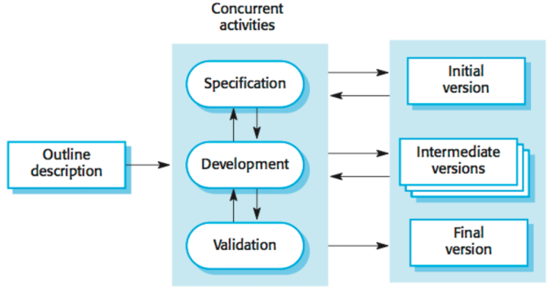
Figure 1.1 Incremental Delivery Model

In the first iteration, we focused on setting up the foundation of the project. This included installing and configuring the required technologies, such as Next.js, Django, Django Channels, and SQLite. The project structure was defined for both the frontend and backend to ensure modularity and scalability. A basic WebSocket connection was implemented to test the feasibility of real-time communication, and the initial SQLite database was set up to support further development.
The second iteration concentrated on backend development and API integration. During this phase, we designed the database schema to accommodate users, threads, messages, and notifications. Django models were created to represent these entities, and the relationships between them were defined. RESTful APIs were developed using Django to handle user authentication, data retrieval, and manipulation. Django Channels was further configured to handle real-time messaging within chat rooms.
In the third iteration, the focus shifted to frontend development. The user interface was developed using Next.js, with attention to creating an intuitive and responsive design. The frontend was integrated with the backend APIs to enable features such as user registration, login, and chat room interactions. WebSocket connections were established on the frontend to facilitate real-time updates, such as instant delivery of messages.
The final iteration of the project focused on extensive testing and optimization of the login and message exchange features. Functional testing was conducted to ensure that the login process worked smoothly, including user authentication. The message exchange system through WebSocket was tested, verifying that messages were sent and received in real time without any issues.

1.6 Report Organization
Chapter 1: Introduction
This chapter introduces the Chat Forum project, highlighting the importance of combining structured discussion forums with real-time chat. It explains the problem statement, objectives, limitations, and the iterative development methodology used to build the system.

Chapter 2: Background Study and Literature Review
This chapter explores the background of online communication platforms, reviewing existing
forums, real-time chat systems, and hybrid approaches. It also discusses related research and technologies, setting the foundation for the proposed Chat Forum system.

Chapter 3: System Analysis
This chapter conducts a detailed analysis of the requirements and functionalities of the "Chat Forum: Combining Structured Discussion with Real-time Messaging" system. Through a thorough examination, we aim to tailor the system to meet the specific needs of users while addressing technical challenges and ensuring the platform is robust and scalable. The feasibility analysis of the system was conducted to ensure that the project is technically, operationally, and schedule-wise viable.

Chapter 4: System Design
This chapter offers an in-depth look at the design principles and architecture that guide the development of the "Chat Forum: Combining Structured Discussion with Real-time Messaging" system. From the design of the user interface to the structural components and data flow, this section lays the groundwork for the next steps in the implementation process. The system is designed to provide a seamless user experience by combining structured discussions in threads with the ability for users to engage in real-time chat.

Chapter 5: Implementation and Testing
This chapter delves into the practical aspects of developing the "Chat Forum: Combining Structured Discussion with Real-time Messaging" system. Using an incremental delivery model, the project was developed in phases, with each phase focused on building and testing core features to ensure the reliability and functionality of the system.

Chapter 6: Conclusion and Future Recommendations
This chapter summarizes the project's achievements, challenges, and impact. It also provides recommendations for future improvements, such as advanced moderation features, mobile optimization, and potential integrations.

CHAPTER 2- BACKGROUND STUDY AND LITERATURE REVIEW

2.1 Background Study
Online communication has evolved significantly over the years, with forums and instant messaging platforms serving as two primary means of digital interaction. Traditional forums provide structured, topic-based discussions, allowing users to engage in meaningful, well-documented conversations. However, they often lack immediacy, making real-time collaboration difficult. On the other hand, instant messaging platforms facilitate quick interactions but frequently lead to disorganized discussions that are hard to navigate.
Chat Forum addresses this gap by integrating the structured nature of forums with the speed of real-time chat, ensuring that discussions remain both organized and immediate. The system enables users to create topic-specific discussion threads while allowing for live participation through WebSockets-powered real-time communication.
The development of Chat Forum is based on key advancements in web technologies, including:
- Next.js and Tailwind CSS for Frontend
- Django for Backend
- WebSockets for Real-Time Communication
- Word2VEC Algorithm for Context Analysis
While existing platforms either prioritize structure (forums) or speed (instant messaging), Chat Forum is designed to combine both, fostering meaningful, interactive, and well-organized discussions.

2.2 Literature Review
Online discussion systems have been the focus of extensive research, particularly in enhancing user engagement and structuring real-time conversations. Various studies and projects highlight the benefits and challenges of different communication models.
Akshatha Samanth, Ramya Suraj, and Vignesh Karkera, along with Professor Alok Ranjan in 2018, documented the Web Wizard platform in the International Journal of Computer Science Trends and Technology (IJCST). The platform offered a community-driven solution for interactive discussions, allowing users to post and respond to queries. The key features included a user-friendly interface, mobile responsiveness, and a content filtration mechanism to prevent inappropriate language. The system also provided offline notifications via SMS and email, ensuring users stay informed. Administrators oversee user activity and moderate discussions to maintain a secure and well-regulated environment. The study emphasizes the integration of real-time data and user-centric design principles to enhance adaptability, scalability, and security in modern online forums.[1]
Archana Nikose, Sakshi Dosani, Shreya Pardhi, Deep Nikode and Anurag Jais, in 2023, conducted a study that explored the development of a real-time chat application using the MERN stack (MongoDB, Express.js, React, Node.js). The application allowed users to create accounts, join chat rooms, and send messages in real-time, leveraging Socket.io for low-latency communication. The paper emphasized user authentication through JWT and the scalability benefits of the MERN stack for building robust, secure, and interactive web applications.[2]
Edeh Michael Onyema, Edeh Chinecherem Deborah, Alhuseen Omar Alsayed, Quadri Noorulhasan Naveed, and Sumaya Sanober, in 2019, conducted a study titled Online Discussion Forum as a Tool for Interactive Learning and Communication, which examined the use of online discussion forums (ODF) in promoting interactive learning and communication among students and teachers. The study focused on the development of the "CSC forum" at Tai Solarin University of Education, Nigeria, and found that ODF enhances student-teacher communication, encourages active learning, and improves students’ digital literacy. However, it also highlighted challenges such as power supply issues, low commitment, and poor internet connections that could hinder the forum's success. The research emphasized the crucial role of teacher involvement in guiding discussions to boost student participation and engagement.[3]

CHAPTER 3- SYSTEM ANALYSIS

3.1 System Analysis

3.1.1 Requirement Analysis
Requirement analysis involved identifying and documenting the necessary features and functionalities to ensure the system meets its intended purpose. The requirements are categorized into functional and non-functional aspects.

3.1.1.1 Functional Requirements
The functional requirements of the system include:
- User Authentication & Access Control – Users must be able to register and log in to access the forum, while admins have additional privileges to manage rooms, users, and content.
- Forum Navigation & Search – Users can navigate different rooms to find relevant discussions and search threads based on keywords to locate specific topics.
- Thread Management – Users can create new threads within a room for discussion, edit their own created threads, and delete their own threads. Admins have the authority to add, edit, and delete any threads in the system.
- Messaging & Discussion – Users can read existing discussions within threads and send messages to participate in discussions.
- Room Management (Admin Only) – Admins can add new rooms to categorize discussions, edit or remove existing rooms when necessary, and manage users within rooms.

Use Case Description
Table 3.2 Use Case for Login
Use Case ID | UC-001
Use Case Name | Login into the System
Primary Actor | User, Admin
Secondary Actor | System

Description | This use case describes the authentication process for users and administrators to access the chat forum
Pre-Condition | The user/admin has valid credentials
Success Scenario | The system successfully logs in the user/admin
Failure Scenario | Invalid credentials, system error
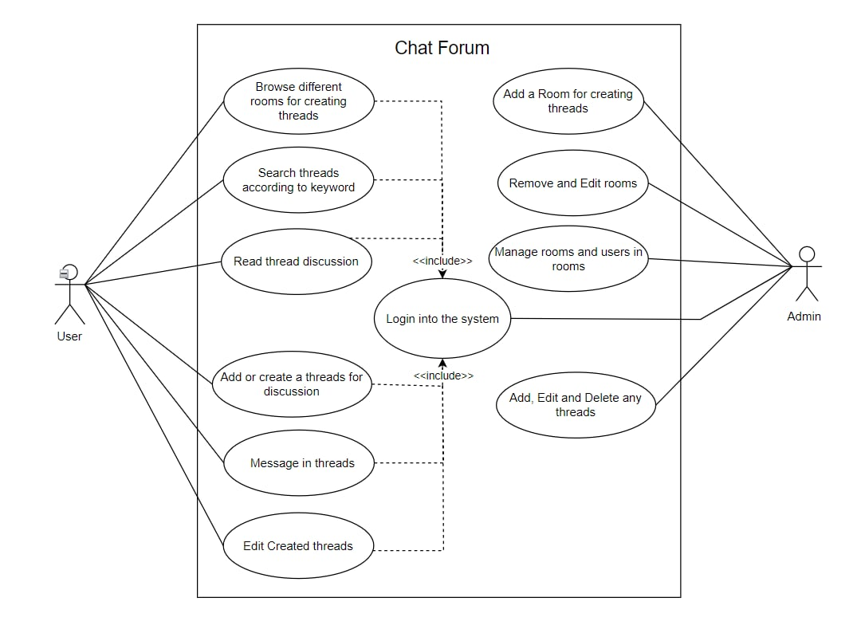
Figure 3.1 Use Case Diagram of Chat Forum

Table 3.2 Use Case for Search Threads
Use Case Id | UC-002
Use Case Name | Search Threads According to Keywords
Primary Actor | Uses
Secondary Actor | System
Description | User search for discussion threads using keywords
Pre-Condition | The user is logged in
Success Scenario | The system retrieves and displays relevant threads
Failure Scenario | No matching thread found, system error

Table 3.3 Use Case for Manage Rooms and Users
Use Case Id | UC-003
Use Case Name | Manage Rooms and Users in Rooms
Primary Actor | Admin
Secondary Actor | System
Description | Admins can manage rooms and assign users.
Pre-Condition | The admin must be logged in with the necessary permissions, and the system must have existing user and room records.
Success Scenario | The Admin successfully logs in, manages rooms, and assigns users to rooms, with a confirmation message from the system.
Failure Scenario | The Admin encounters login issues, system errors, or permission issues, preventing successful room management or user assignment.

3.1.1.2. Non-Functional Requirements
Non-functional requirements of the system include:
- Security – Implemented CSRF protection to prevent cross-site request forgery attacks, secure user authentication using password hashing, and enforce role-based access control for admins and users.
- Usability – Ensured the interface is user-friendly and interactive while providing search functionality for quick access to relevant threads.
- Maintainability and Extensibility – Utilized a modular architecture to allow future upgrades and follow clean coding standards for easier debugging and maintenance.

3.1.2 Feasibility Analysis
Feasibility analysis evaluates whether the Chat Forum system is viable based on technical, operational, schedule, and economic aspects.

Technical Feasibility – The system is designed for compatibility with large-screen devices (laptops, desktops), operates on a web-based platform using Next.js for the frontend and Django for the backend, utilizes Web-Sockets for real-time messaging and dynamic content updates, and requires an active internet connection for user interactions in discussion rooms.

Operational Feasibility – The UI is intuitive and user-friendly, with clear labels and proper categorization of discussion rooms enhancing usability, while search functionality and real-time chat ensure seamless user engagement; admins have moderation tools to keep the platform well-organized.

Schedule Feasibility – The project faced delays due to challenges with real-time Web-Socket implementation and machine learning model creation, as well as complexities in authentication (e.g., role-based access control), but core functionalities were successfully implemented, with future iterations focusing on user experience. The final system was finished on time as scheduled in the gantt chart.

Table 3.4 Work Breakdown Structure of the Project
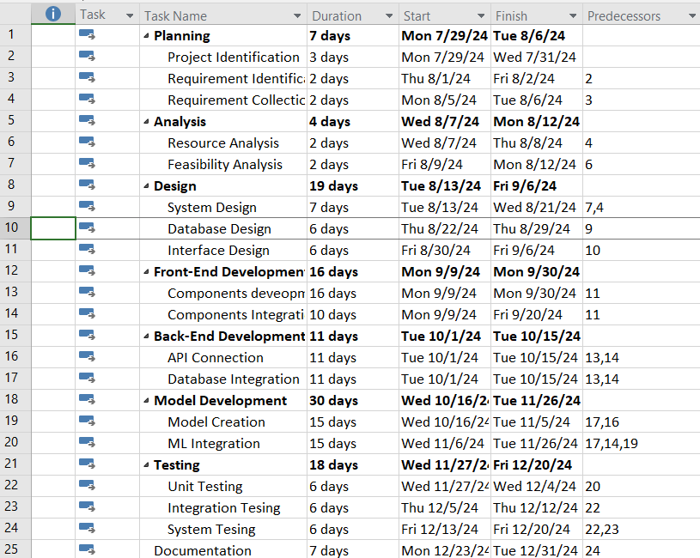

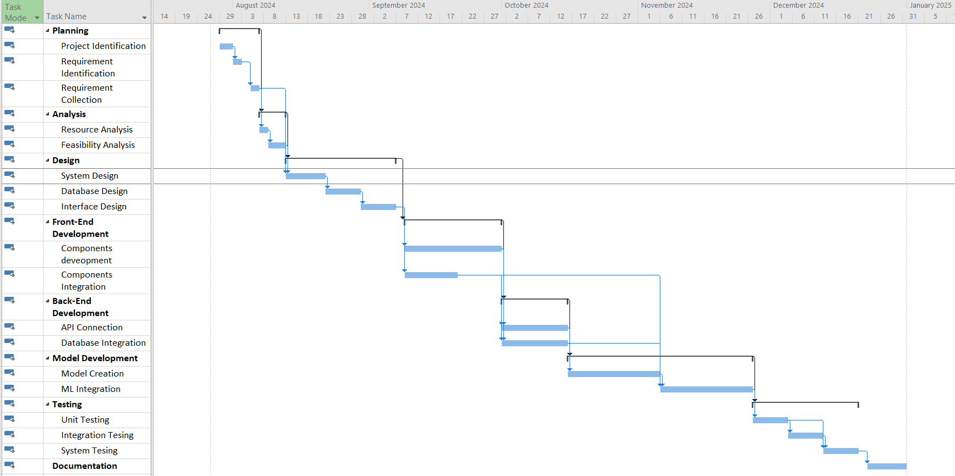

Figure 3.2 Gantt Chart of the project

3.1.3 Analysis
3.1.3.1 Object Modelling with Class Diagram
The class diagram defines the core relationships in the Chat Forum system.

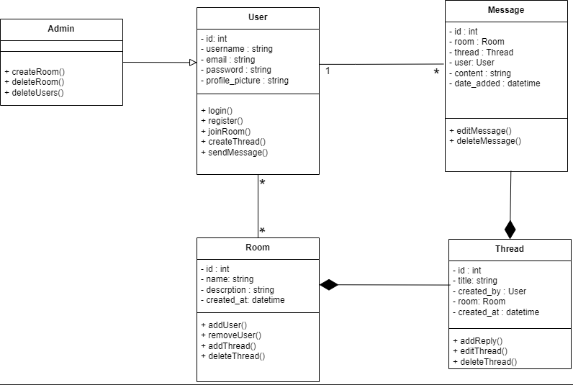
Figure 3.3 Class Diagram of Chat Forum
This class diagram represents a chat forum system where Rooms contain multiple Threads, and each thread belongs to a specific room. Users can join multiple rooms, create threads, and send messages within them. Each Thread is created by a user and consists of multiple Messages, which are posted by users to facilitate discussions. Messages are linked to both a thread and a room, ensuring organized communication. The Admin manages the system by creating and deleting rooms and users. This structure ensures a well-organized forum where users can engage in discussions while administrators oversee the platform.

3.1.3.2 Dynamic Modelling with Sequence Diagram
The sequence diagram highlights interactions between the User, Chat Forum System, System Database.
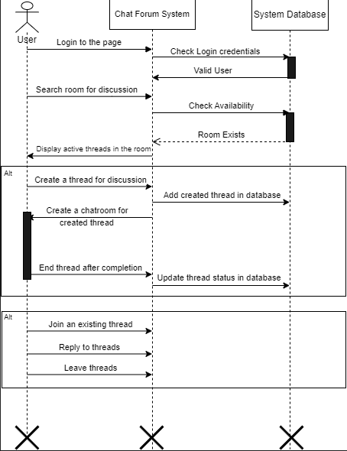

Figure 3.4 Sequence Diagram of Chat Forum

The diagram illustrates the user interaction with the Chat Forum system starting with login authentication, where the system validates user credentials with the ones in the database. Once authenticated, users can search for discussion rooms, with the system checking room availability. After finding an existing room, the user is presented with active discussion threads. From there, two alternative paths are shown: users can either create a new discussion thread (which gets added to the database and includes a dedicated chatroom) or they can join in existing threads and reply to the queries. The diagram effectively captures the sequential interactions between the user, the forum platform, and the underlying database, highlighting both the authentication process and the core discussion functionalities that form the backbone of the forum system.

3.1.3.3 Process Modelling with Activity Diagram
The activity diagram outlines the dynamic flow of the system, starting at the "Start" node and guiding the user through various actions and decisions. It begins by determining whether the user is registered, notifying and directing them to register if necessary.

Figure 3.5 Activity Diagram of Chat Forum
For registered users, the system facilitates login and verifies authentication. In the case of unsuccessful authentication, the user is notified, and the process halts. Upon successful authentication, the user gains access to two primary pathways: entering a room to browse or create threads, or joining previously accessed threads to reply to queries. These activities flow seamlessly, ensuring an intuitive and structured user experience. The diagram concludes at the "End" node, offering a unified representation of the system's functionality, from registration and authentication to thread interactions.

CHAPTER 4- SYSTEM DESIGN
4.1 Design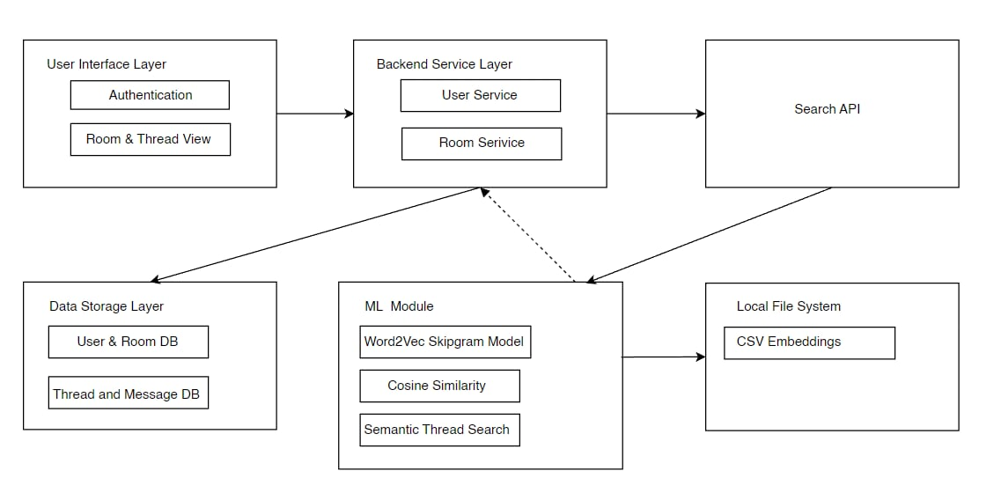
Figure 4.1 High Level System Design
The high level system design of ChatForum is shown in the above figure. The following steps were carried out throughout the project development:
- User Interface Layer
The front-end component users directly interact with, containing the Authentication module for login/registration and the Room & Thread View for browsing and participating in forum discussions.
- Backend Service Layer
This layer processes all business logic, with account-related operations and room and thread structure management, serving as the connection between the UI and data layers.
- Data Storage Layer
This layer stores information related to user, rooms, threads and messages.
- Machine Learning Module
Following things were carried out in this layer:
Dataset Description
Foremost, the dataset was collected from kaggle.com, a professional online platform for data science and machine learning. It provides datasets, coding competitions, and a collaborative environment for data scientists and AI practitioners.
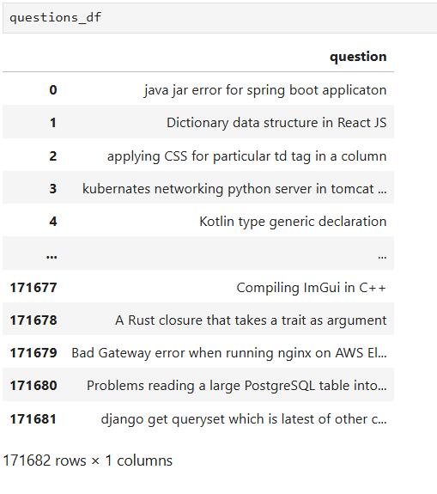
Figure 4.2 Dataset Description

From the dataset figure above, we can see the dataset consists of questions related to technical fields. There are total of 171682 unique question sets which are used to generate the vocabulary for the model on the later phase.

Data Pre-Processing
To improve the quality of textual data, various preprocessing techniques were applied. These included data cleaning, tokenization, vocabulary filtering, and context-based training data preparation.

Model Training
After preprocessing the textual data, the Word2Vec Skip-gram model was trained to generate meaningful word embeddings. The model was designed to capture contextual relationships between words based on the word pairs generated from the vocabulary.

Word Embeddings Saving
Finally the embeddings were generated and saved in a csv file which were used in the backend to fetch related threads from the provided search query.
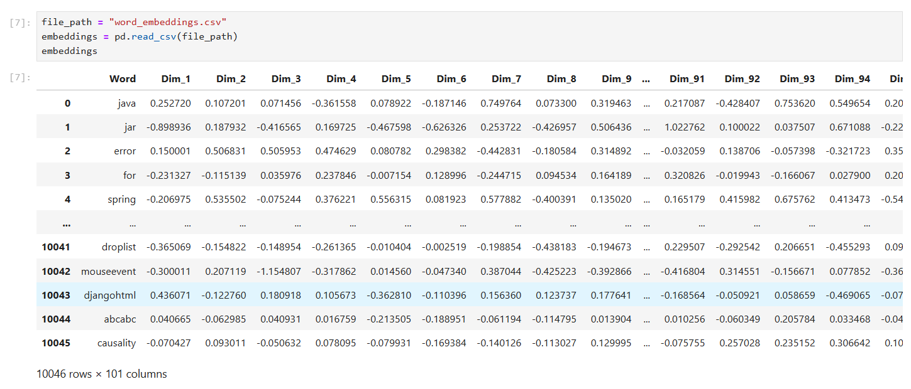
Figure 4.3 Word Embeddings

4.1.1 Refined Class Diagram
The refined class diagram contains more detailed form of our application class diagram with full specification of methods and attributes of a class. More methods and attributes are associated with the entities in the refined class diagram.The "Admin" class oversees system management, including room and user operations. The "Room" class serves as a container for threads, while the "Thread" class facilitates topic-specific discussions and links with the "Message" class for user interactions. The "Message" class captures user communication, including content, timestamps, and engagement metrics like upvotes and downvotes.These interdependencies and associations establish a unified framework, streamlining real-time communication and structured interactions for the ChatForum platform.
Figure 4.4 Refined Class Diagram of Chat Forum
Added Attributes in the Refined Class Diagram:
- upvote
- downvote
Added Methods in the Refined Class Diagram:
- upvoteMessage()
- downvoteMessage()
- voteMessage()
- thread_count()

4.1.2 Refined Sequence Diagram
The refined sequence diagram gives a thorough perspective of how actually the application works. It properly shows an interactions between the User, Chat Forum System, System Database, and ML Model. Compared to the sequence diagram before this diagram provides detailed perspective of working of our application.

Figure 4.5 Refined Sequence Diagram of Chat Forum

It begins with user login, session creation, and redirection to the dashboard. The User navigates to active threads and uses the ML Models Skip-gram technique to search for threads with similar keywords. Filtered threads are retrieved and displayed. Upon entering a thread, existing messages are shown, and new messages are stored in the database. The process concludes with session clearing upon logout, showcasing seamless coordination and ML integration for enhanced thread search.

4.1.3 Component Diagram:
The provided component diagram illustrates the structure of a Chat Forum Web Application, highlighting different components and how they interact. The primary web application interacts with various components to manage distinct functionalities. User Authentication, Room Management, Thread Management, and Semantic Search are essential service elements, with each tasked with particular functions.These elements connect with a Database that holds User Data, Room Data, and Thread Data via the supplied interfaces. The Semantic Search feature connects to the Word2Vec Skip-Gram model, improving search precision with word embeddings and cosine similarity. Furthermore, the Word2Vec Skip-Gram module connects with a Local File System, where CSV Embeddings are kept. The chart employs a modular design, utilizing given and needed interfaces (shown as lollipops and sockets) to maintain clear
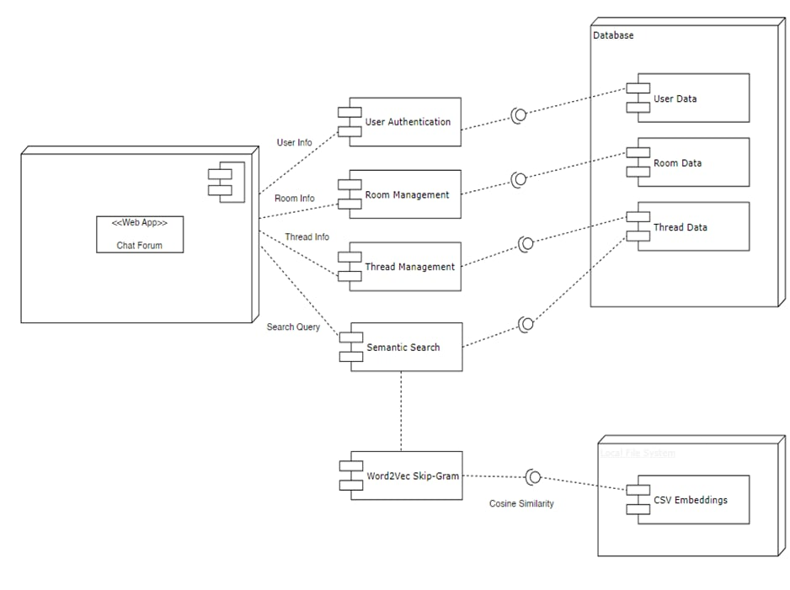
dependencies and communication pathways among components.
Figure 4.6 Component Diagram of Chat Forum

4.1.4 Deployment Diagram:
The deployment diagram highlights the system’s architecture, connecting the Frontend (User Interface), Backend Server (Django), Database (SQLite), and Machine Learning module (Skip-gram model). The Frontend communicates with the Backend Server to handle user requests, which integrates with the Database for data management and the Machine Learning module for enhanced thread search functionality. This setup ensures efficient interaction and a seamless user experience.
Figure 4.7 Deployment Diagram of Chat Forum

4.2 Algorithm Details
The algorithm used for query processing in the chat forum project is based on the SkipGram model with Negative Sampling, a well-known technique in Natural Language Processing (NLP) for learning word embedding. The primary objective of the Skipgram model is to predict context words (words surrounding a target word) from the target word itself. This enables the model to capture semantic relationships between words, which is essential for processing user queries and retrieving relevant threads in the forum.

4.2.1 Skipgram Model with Negative Sampling:
The Skipgram model learns word embedding such that words appearing in similar contexts have similar embedding. This is achieved through training on pairs of words where one word is the target (centre) word, and the other words are context (surrounding) words.
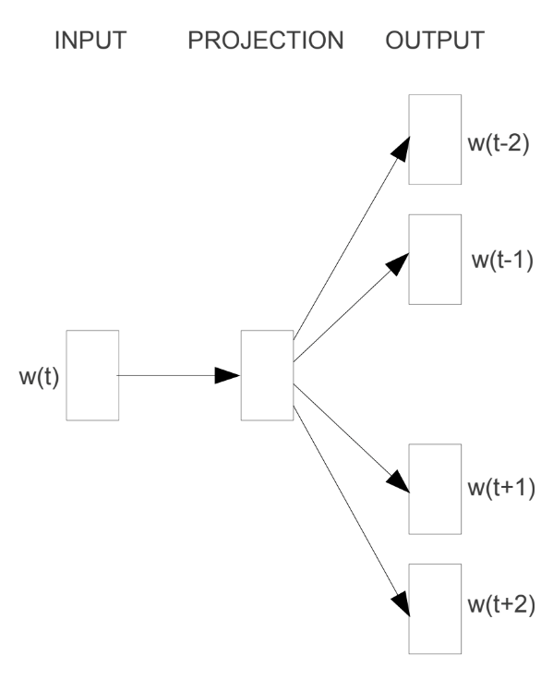

Figure 4.8 Skipgram Model

To improve training efficiency and handle large vocabularies, Negative Sampling is employed. Instead of updating the weights for all words in the vocabulary, the model only updates the weights for the target word, the context word, and a small set of negative samples (unrelated words).

4.2.2 Loss Function and Training Objective
The SkipGram model with Negative Sampling optimizes the likelihood of predicting correct context words while minimizing the probability of predicting incorrect (negative) words. The training objective is to maximize the probability of observing positive (target-context) word pairs while minimizing the probability of observing negative samples.

Probability Formulation
For a given target word $w_{t}$, the probability of a correct context word $w_{c}$ ​ is defined as:
P(w_{c}|w_{t}) = $σ(v_{w_{c}}.v_{w_{t}})$
where:
- $v_{w_{c}}$​​ is the embedding of the context word,
- $v_{w_{t}}$​​ is the embedding of the target word,
- σ(x) = $\frac{1}{1+e^{-x}}$​ is the sigmoid activation function.

For negative sampling, we select a set of k negative words w_{n}​, which are randomly chosen from the vocabulary (excluding the actual context word). The probability of a negative sample being a context word should be minimized:
P(w_{n}|w_{t}) = $σ(-v_{w_{n}}.v_{w_{t}})$
where $v_{w_{n}}$ is the embedding of a randomly sampled negative word.

Loss Function
The total loss function for a single training example consists of two parts:
- Positive Loss: Encourages the model to maximize the probability of the correct context word.
- Negative Loss: Encourages the model to minimize the probability of negative words being considered context words.

$$L= -log{σ}\left(v_{w_{c}}.v_{w_{t}}\right)-\sum_{i=1}^{K}{\log{σ}(-v_{w_{n}}.v_{w_{t}})}$$

where, K represents the number of negative samples per word pair. The value of K is usually experimentally determined based on model performance. If K is too low, the model may not learn meaningful word embedding, while if K is too high, training may become computationally expensive.
Here,
- The first term maximizes the probability of the correct context word.
- The second term minimizes the probability of incorrect (negative) words.

4.2.3 Model Inference
Once the model is trained, the learned word embedding can be used to find similar words for a given query. The similarity between two words is computed using cosine similarity:
cosine_similarity (v1,v2) = $\frac{v1⋅v2}{\left|v1\right||v2|}$
Where:
- v1 ​and v2 are the embedding of the two words.
- The result is a value between -1 and 1, where 1 indicates high similarity and -1 indicates dissimilarity.
The most similar words to a given word are found by computing cosine similarities between the word's embedding and all other word embedding in the vocabulary.

CHAPTER 5- IMPLEMENTATION AND TESTING

5.1 Implementation

5.1.1 Tools Used
Frontend: Next.Js, TailwindCSS
Backend: Django-Rest-Framework, Web-Socket Programming
Database: SQLite
Testing: Selenium

5.1.2 Implementation Details Of Modules
i. Registration Module
The registration module enables users to create an account by entering their personal details, including their name, email address, and password. This module ensures the secure storage of user information within the system. When a user submits the required details, the input is captured and assigned to different variables. The provided name, email, and password undergo validation, and if the information is invalid or already exists in the database, appropriate error messages are displayed. If the credentials are valid and the email is correctly formatted, the user account is successfully stored in the database.
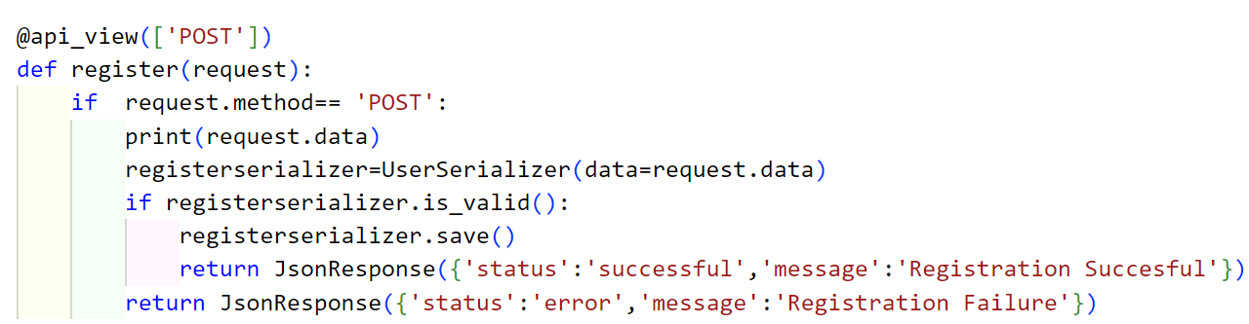
Figure 5.1 Implementation of Registration Module

ii. Login Module
The login module allows registered users to access the system by providing their login credentials such as email address and password. This module is used when the user is properly saved in the database and is authenticated as shown in below figure.

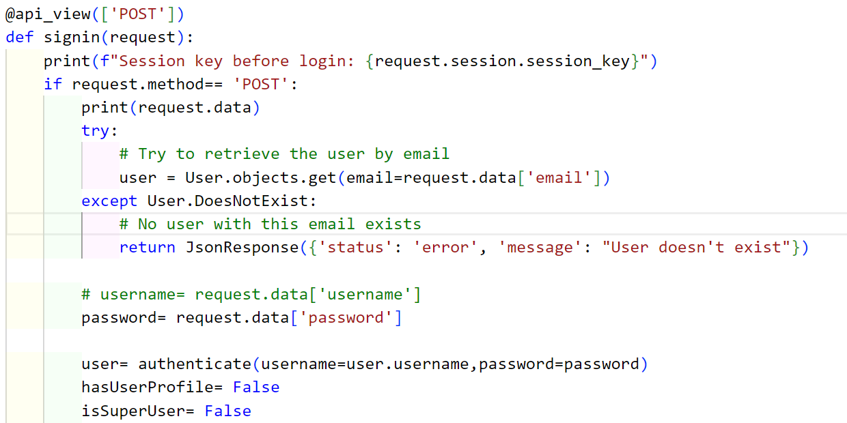

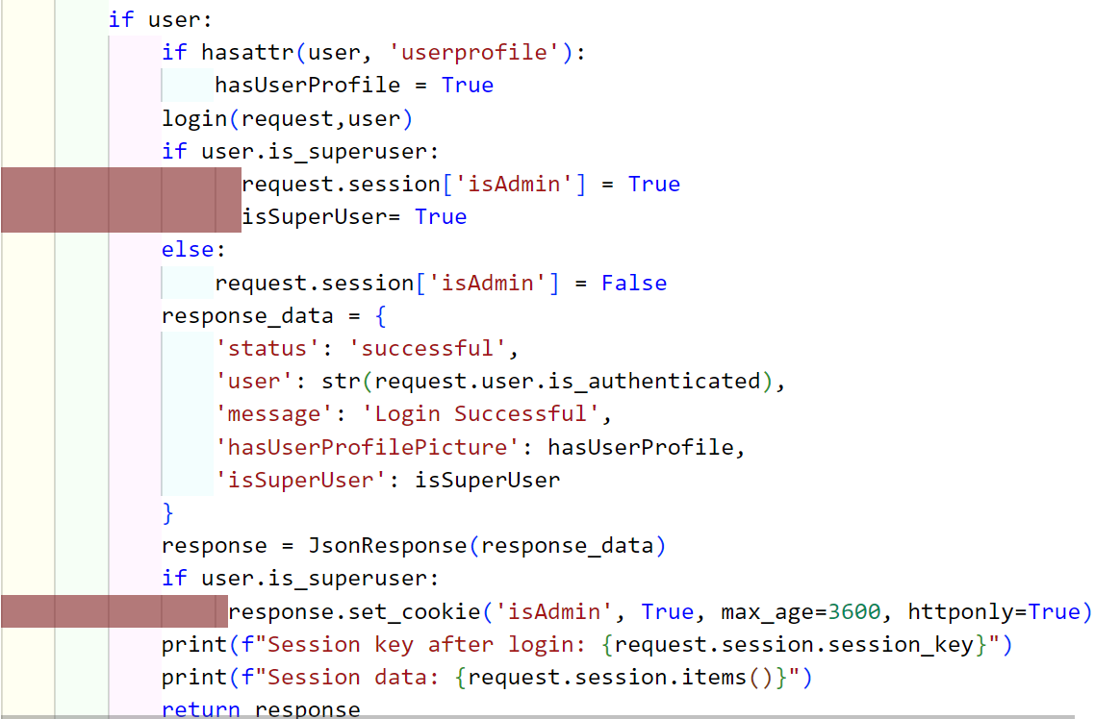

Figure 5.2 Implementation of Login module

iii. Query Based Thread Search Module:
This is the main module which accepts the thread searches words and returns the threads by comparing the requested inputs and all other words in the threads and returns the threads that has words with high cosine similarity to the searched words.
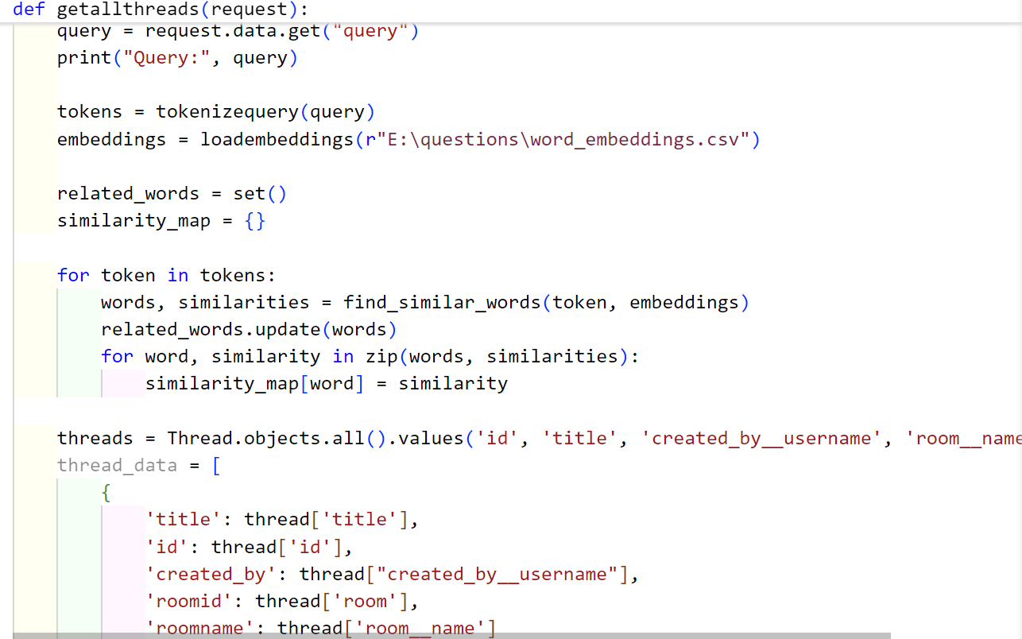

Figure 5.3 Implementation of query based thread search module

iv. Search thread module:
This module is responsible for searching and ranking threads based on their relevance to a given set of related words. It first retrieves all messages along with their associated threads from the database and tokenizes the content of each message. It then compares the words in the messages with the provided related words and calculates a similarity score for each thread using a predefined similarity mapping. If a thread contains relevant words, the highest similarity score among the matched words is stored for that thread. After identifying the relevant threads, the module fetches additional details such as the thread title, creator's username, and the room to which the thread belongs. Finally, it compiles a list of matching threads, sorts them in descending order based on their similarity scores, and returns the results. This functionality enhances the search experience by identifying and ranking the most relevant threads, making it easier for users to find discussions related to their queries.
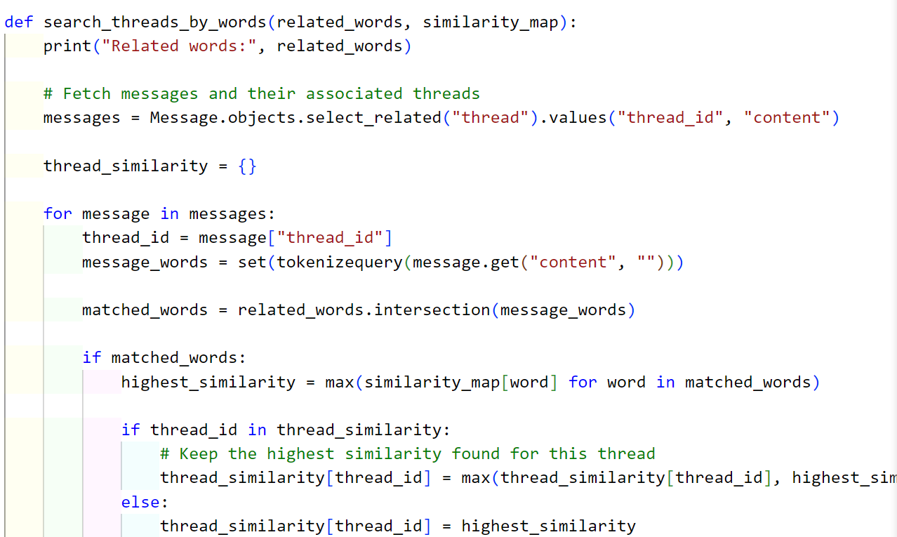
Figure 5.4 Implementation of Search Threads by Related Word module

5.1.3 Implementation Details Of the Algorithm
The process of generating word pairs for training was carried out through several key steps:
- Tokenization & Pre-processing
  - The text was converted to lowercase.
  - Special characters and non-alphabetic symbols were removed, keeping only words.
  - Words with a length of one or less were discarded.
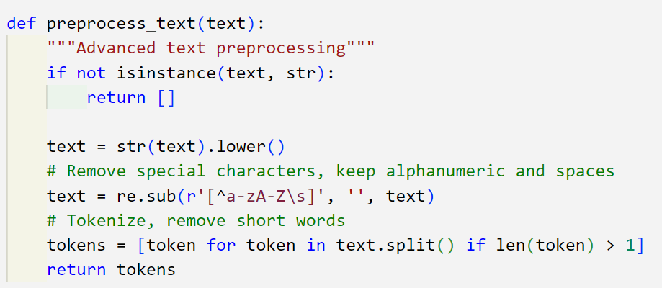
Figure 5.5 Tokenization of search query
- Building Vocabulary
  - A vocabulary was created by counting the occurrences of words across all tokenized questions.
  - Only words that appeared at least a certain number of times (minimum count threshold) were retained in the vocabulary.
  - A special padding token was added to the vocabulary to handle cases where sequences needed to be aligned.
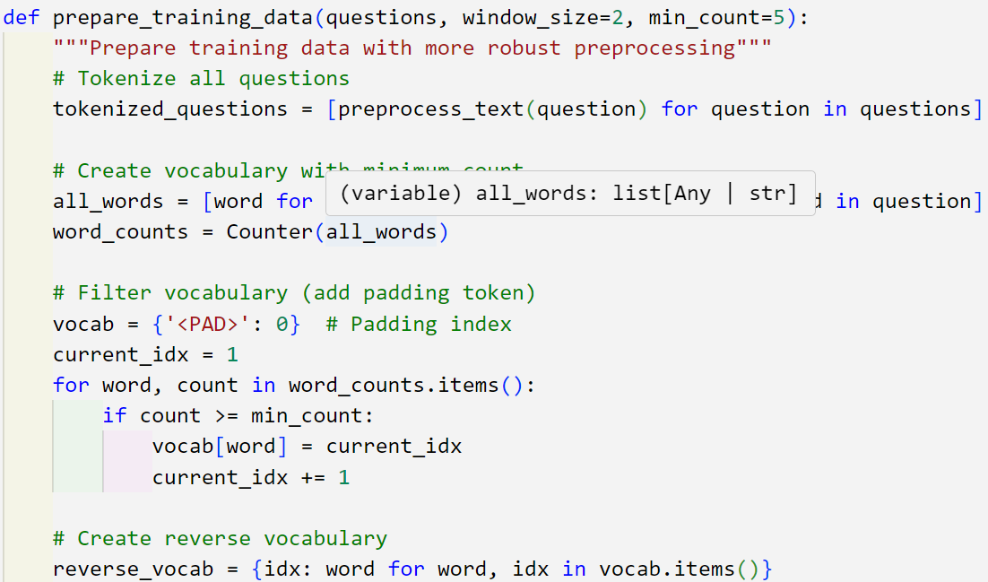

Figure 5.6 Training data preparation for machine learning

- Converting Words to Indices
  - Each word was assigned a unique index based on its position in the vocabulary.
  - A reverse mapping was also created to convert indices back to words.
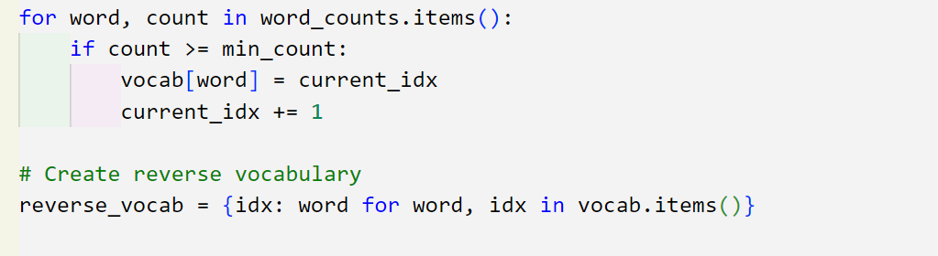
Figure 5.7 Converting words to indices
- Sliding Window Context Selection
  - Each tokenized sentence was processed word by word.
  - A sliding window moved through the sentence, selecting a target word and its surrounding words as context words within a defined range.
  - For each target word, context words were selected from the left and right within the window size.
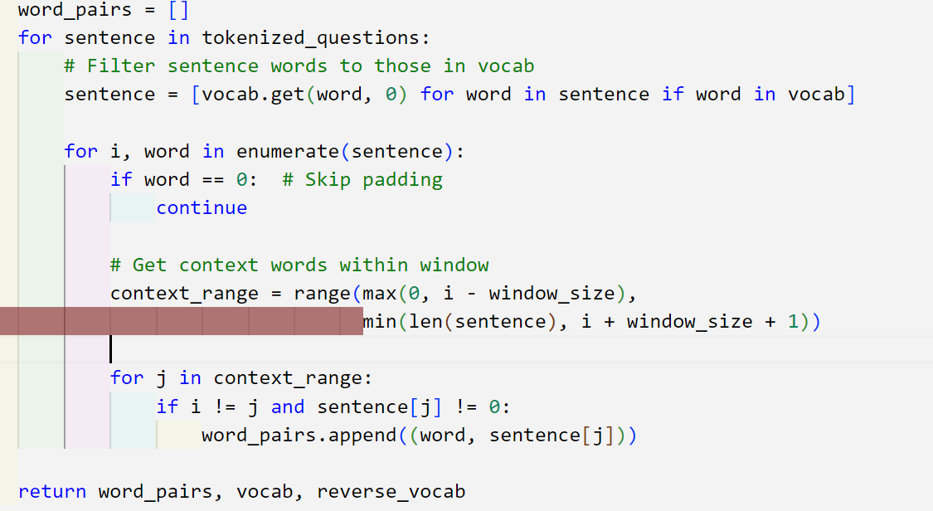
Figure 5.8 Sliding window for selection of context words

- Generating Word Pairs
  - For each occurrence of a target word, multiple word pairs were created, where:
    - The target word was the central word in the window.
    - Each selected context word within the window became the corresponding context word for that target.
  - Any words that were not in the vocabulary were ignored.
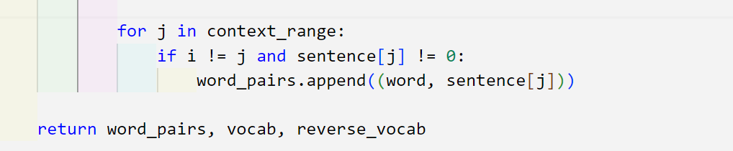
Figure 5.9 Generation of word pairs

5.1.3.1 Negative Words Generation
The negative sampling process was implemented as follows:
- Vocabulary Size Determination
  - The total number of words in the vocabulary was obtained after filtering based on frequency.
- Random Selection of Negative Samples
  - For each batch of training data, a set number of negative samples were selected.
  - The selection was performed using np.random.choice(), where words were randomly drawn from the vocabulary (excluding the padding token).
  - The number of negative samples per training instance was predefined, ensuring consistency across training.
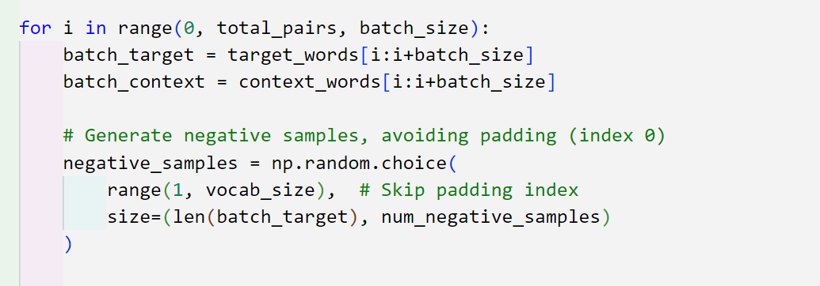
Figure 5.10 Generation of negative samples for words
- Embedding Retrieval
  - Once sampled, the negative words were converted into their respective embeddings using the output embedding layer.
  - These negative embeddings were then used in the loss computation, contributing to the model's learning process.
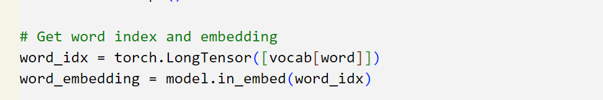
Figure 5.11 Embedding Retrieval

5.1.3.2 Vectorization of Words
1. Initializing Word Embeddings
In our SkipGram model, words are represented as dense vectors (embedding of 100d). These embedding are initialized using Xavier Initialization to ensure a good starting point, which helps in stabilizing training and prevents vanishing or exploding gradients.
nn.init.xavier_uniform_(self.in_embed.weight)
nn.init.xavier_uniform_(self.out_embed.weight)
Additionally, we set the embeddings for the padding index (<PAD>) to zero so that they do not interfere with training:
with torch.no_grad():
self.in_embed.weight[0].fill_(0)
self.out_embed.weight[0].fill_(0)
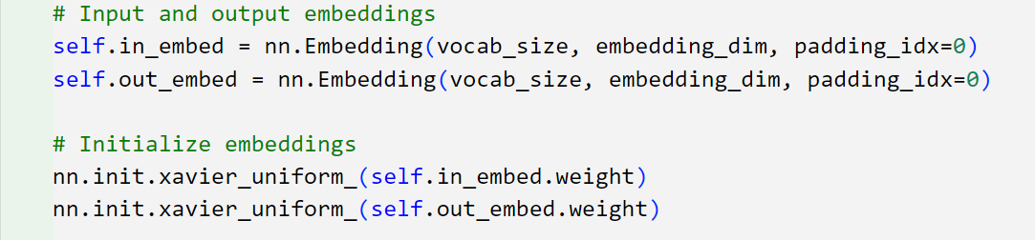
Figure 5.12 Initialization of word embedding using Xavier Initialization

2. Forward Propagation
During training, the SkipGram model takes a target word and predicts context words, while also handling negative samples.
- Input Processing
The input word, context word, and negative samples are first converted into embedding vectors using the embedding layers (in_embed and out_embed).
input_embed = self.in_embed(input_word)
pos_context_embed = self.out_embed(context_word)
neg_context_embed = self.out_embed(negative_words)

- Dot Product Calculation
The model calculates the dot product between the input word embedding and the context word embeddings for positive samples.
pos_loss = torch.sum(input_embed * pos_context_embed, dim=1)
pos_loss = -torch.log(torch.sigmoid(pos_loss) + 1e-10)
For negative samples, the dot product is computed and negated before applying the sigmoid function to reduce the value of dot product and hence its probability. This is done because we want lower probability for negative samples.
neg_loss = torch.bmm(neg_context_embed, input_embed.unsqueeze(2)).squeeze()
neg_loss = -torch.sum(torch.log(torch.sigmoid(-neg_loss) + 1e-10), dim=1)

- Loss Calculation
The final loss is the sum of the positive and negative loss terms, which is then averaged over the batch.
return torch.mean(pos_loss + neg_loss)
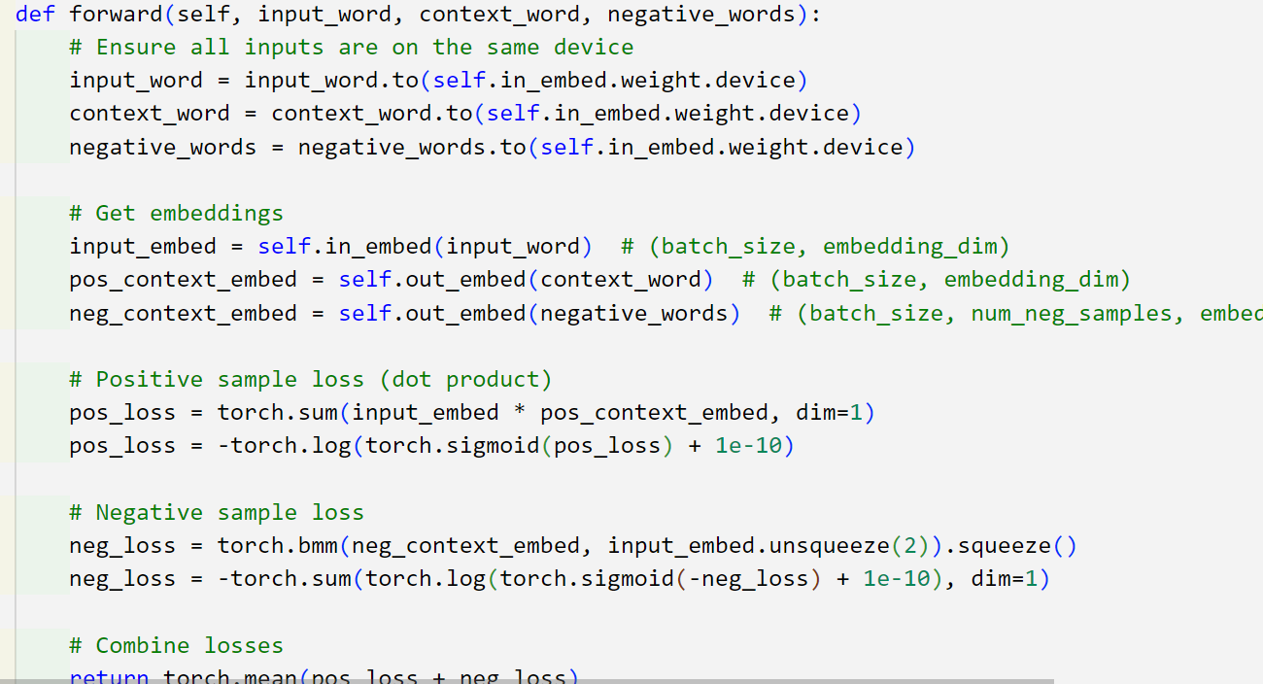
Figure 5.13 Skipgram Model Forward Propagation

3. Training Process
The model is trained using the Adam optimizer, which adapts the learning rate for each embedding weights in self.in_embed and self.out_embed dynamically. It allows larger updates for rarely changing parameters and smaller updates for frequently changing ones, leading to faster convergence and better stability.
Additionally, we use a StepLR scheduler to gradually reduce the learning rate after 10 epochs. By decreasing the learning rate gradually, we prevent overshooting the optimal solution and refine the learned embeddings over time ensuring stable convergence.

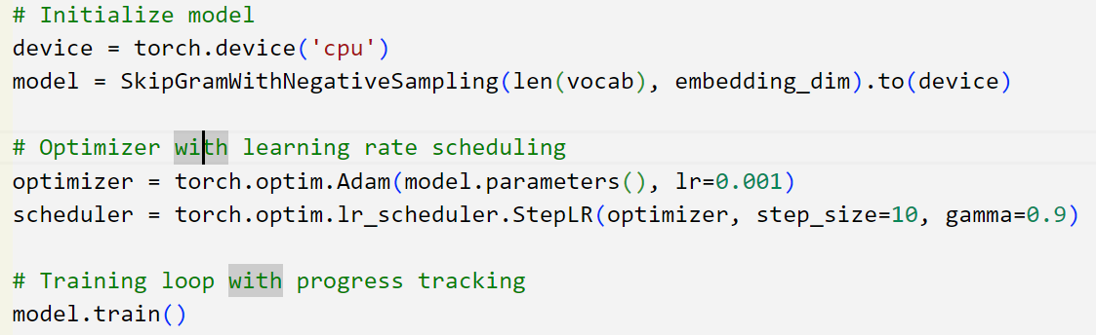
Figure 5.14 Optimizer and Learning Rate Scheduling

5.2 Testing

5.2.1 Test Case for Login Testing
The unit testing process focused on verifying the successful login of users. Selenium was used to automate this testing, ensuring accuracy and efficiency.

Table 5.1 Test Case for User Login
Test Case Name | User Login
Test Case ID | T001
Test Case Description | Verify if the user currently trying to log in is authenticated or not
Test Priority | High
Prerequisite | User provides email and password
Post Condition | The authenticated user gains access to their dashboard

Test Execution Steps:

SN | Action | Test Steps | Expected Output | Actual Output | Test Result
1 | Navigate to the login page | User navigates to login page | User should be redirected to login page | User is redirected to login page | PASS
2 | Login using incorrect credentials | Email: user@gmail.com  Password: user  Click 'Login' | Error prompt: 'Incorrect email or password' | Error prompt: 'Incorrect email or password' | PASS
3 | Login using correct email but incorrect password | Email: anish@gmail.com  Password: user  Click 'Login' | Error prompt: 'Incorrect email or password' | Error prompt: 'Incorrect email or password' | PASS
4 | Login using correct credentials | Email: anish@gmail.com  Password: anish  Click 'Login' | User should be logged in and redirected to dashboard | User is logged in and redirected to dashboard | PASS

5.2.2 Test Case for Message Exchange Testing
The system testing process involved verifying the successful exchange of messages between two users within a thread. Selenium was utilized to automate this testing, ensuring reliability and efficiency.
Table 5.2 Test Case for Message Transmission
Test Case Name | Chat Message Transmission
Test Case ID | T001
Test Case Description | To verify that a user can send a chat message and another user in the same chat room can receive it successfully.
Test Priority | High
Prerequisite | Users are logged in the system and joined the thread chatroom
Post Condition | Chat messages are properly displayed in the chat window and accessible by other users in the room
Test Execution Steps:
SN | Action | Test Steps | Expected Output | Actual Output | Test Result
1 | Login | User Anish and User Bipesh log in to the system | Users should be logged in successfully | Users are logged in | PASS
2 | Join Chat Room | User Anish and User Bipesh enter the same chat room | Both users should be in the chat room | Both users are in the chat room | PASS
3 | Send Message | User Anish sends message: "This is a test message sent by Anish" | Message should be transmitted | Message is transmitted | PASS
4 | Receive Message | User Bipesh should see "This is a test message sent by Anish" | Message should appear without delay | Message appears without delay | PASS

5.2.2 Real-Time Test Scenario
- Test Scenario 1: Login Testing
Test Objective: To Test User Login.
Test Data: User email and password.
Expected Output: Successful Authentication of User.
Actual Output:
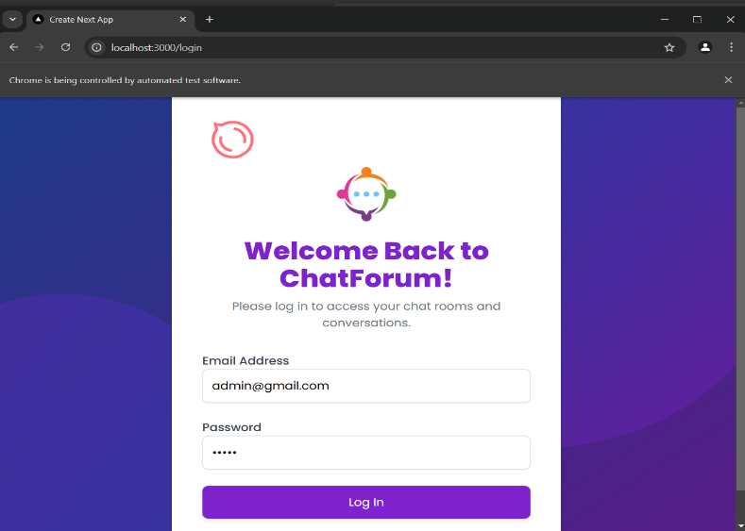

Figure 5.15: Login Testing Output

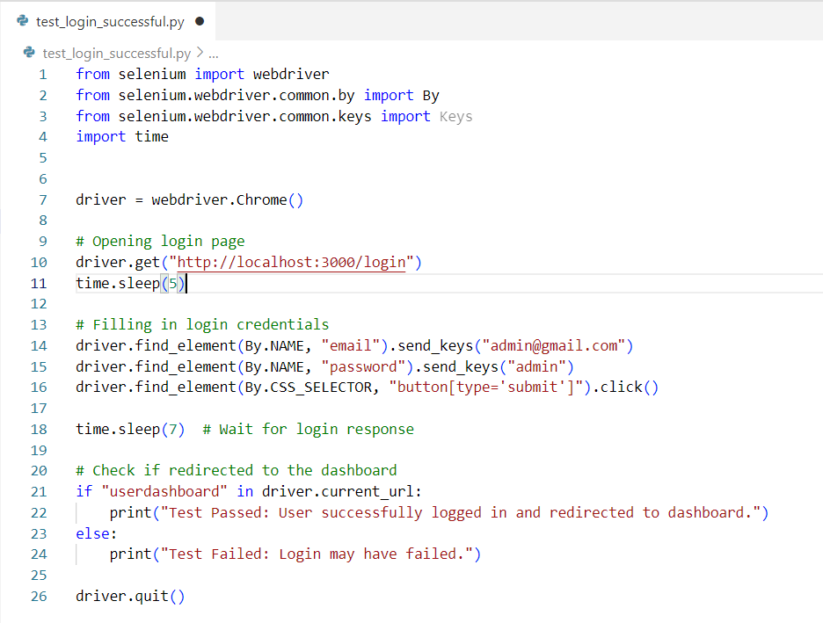
Figure 5.16 Selenium code for login testing
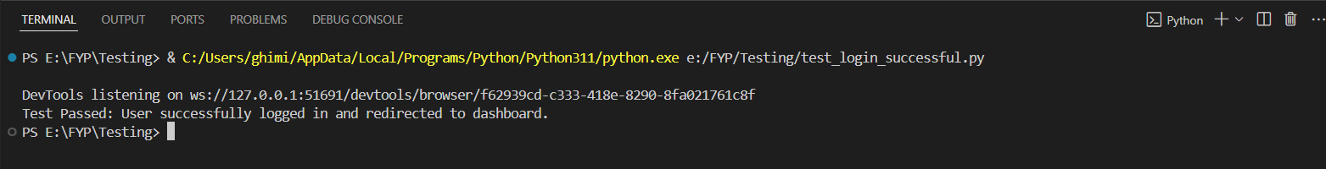
Figure 5.17 Successful login testing output

- Test Scenario 2: Message Exchange Testing
Test Objective: To Test Message Exchange between the users
Test Data: User email, password and test message.
Expected Output: Successful Message Exchange.
Actual Output:

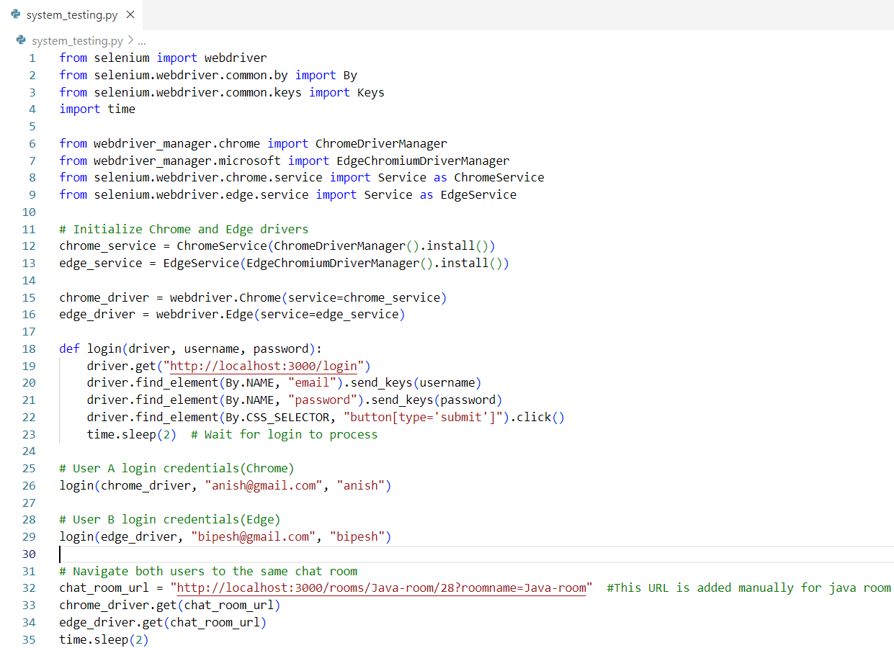

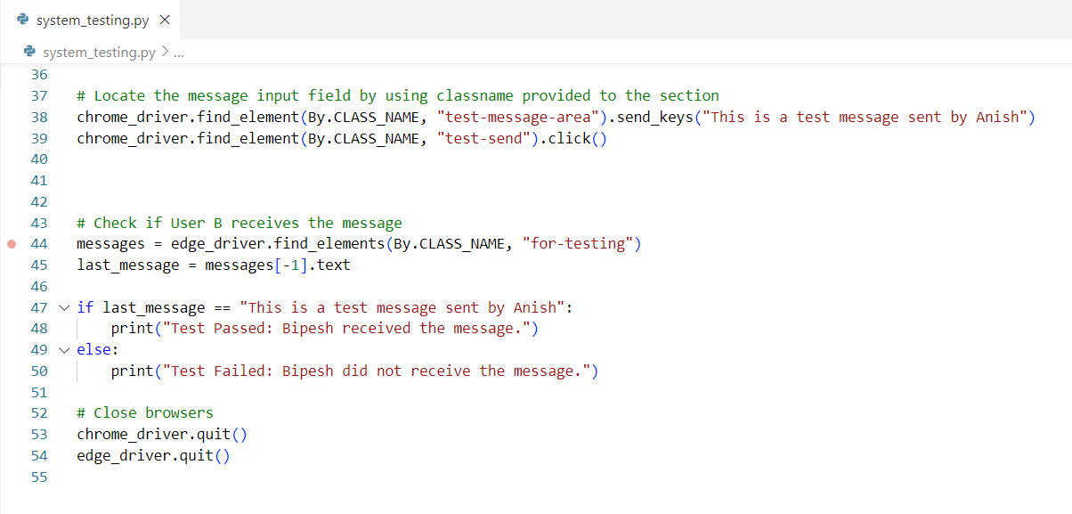
Figure 5.18 Selenium Code for Message Exchange Testing

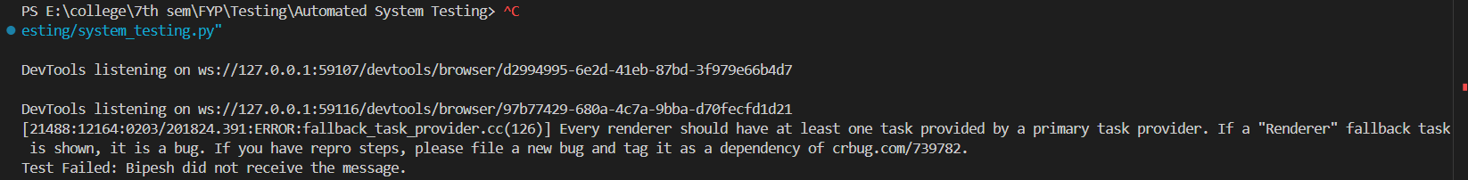
Figure 5.19 Failure output for message exchange testing

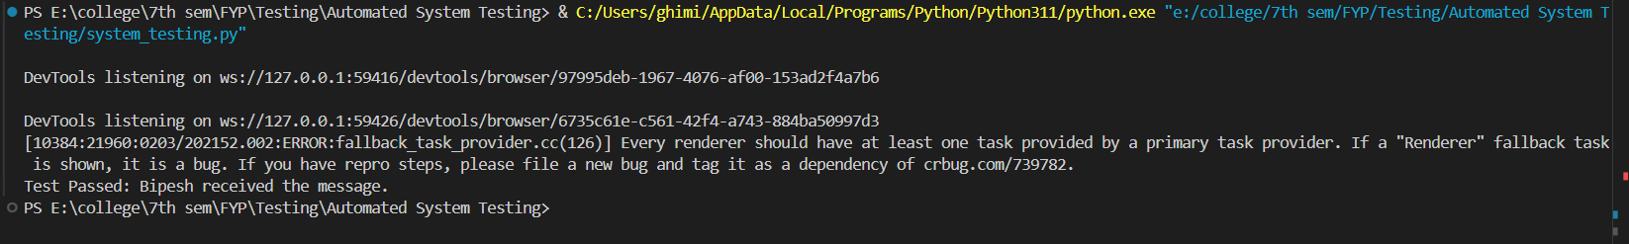
Figure 5.20 Success output for message exchange testing

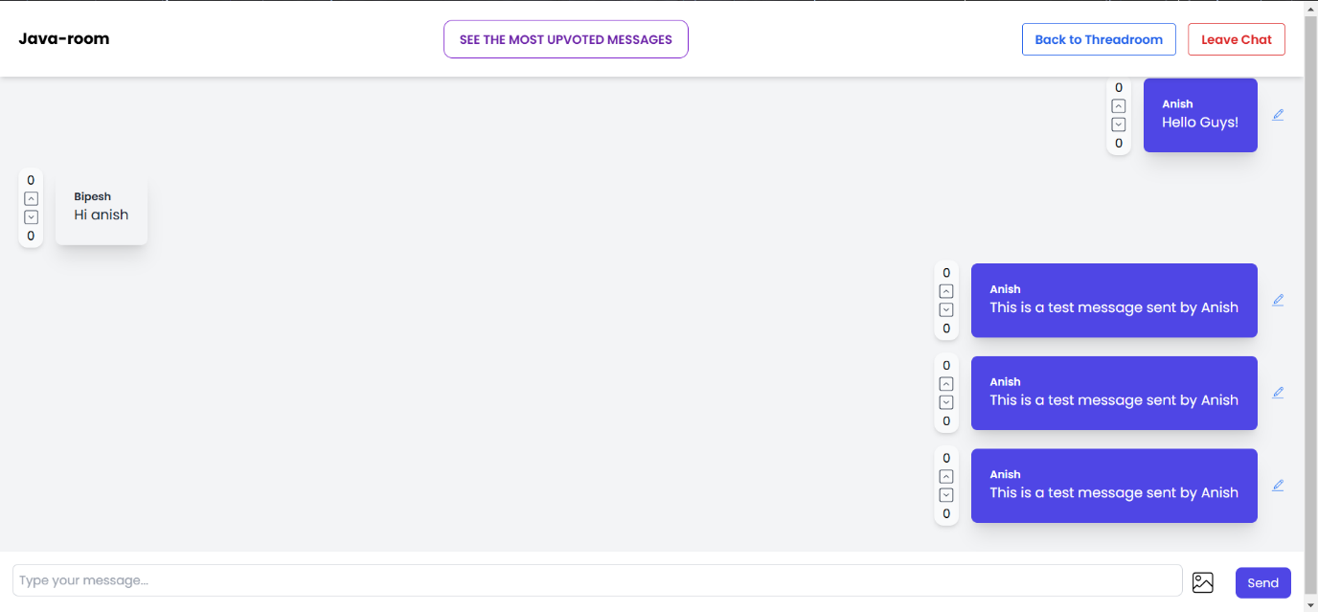
Figure 5.21 Message exchange testing process

5.3 Result Analysis
The Word2Vec model was successfully trained over 20 epochs, demonstrating a consistent decrease in average loss from 0.0026 to 0.0019, reflecting effective learning. Notably, the loss stabilized after Epoch 9, indicating that the model had likely reached convergence. This suggests that, beyond this point, further training would offer diminishing returns.

Training Performance
The training process exhibited variability in iteration speeds, with the fastest iteration recorded at 50.08 it/s (Epoch 13) and the slowest at 31.66 it/s (Epoch 18). This difference in training speed can be attributed to factors such as system load and model convergence dynamics.
Beyond Epoch 10, the improvement in loss became minimal, which implies that early stopping could be applied to optimize training time and computational resources without sacrificing model performance.

Model Performance Evaluation and Suggested Improvements
To evaluate the model’s effectiveness, we computed cosine similarity scores between selected words. The results indicate that the model successfully captures semantic relationships:
Table 5.3 Model Performance and Evaluation
Target Word | Most Similar Word | Similarity Score
oop | overloading | 0.50
oop | inheritance | 0.47
javascript | jquery | 0.61
javascript | vanilla | 0.48
react | native | 0.64
react | redux | 0.59
react | usecontext | 0.55

These similarity scores, computed using cosine similarity between a target word and its related words, validate that the model effectively captures semantic relationships and groups similar words within the vector space.
However, improvements can still be made. To further enhance the model’s performance, the following strategies are recommended:

1. Hyper parameter Tuning
- Negative Sampling (K): Experimenting with different values of negative samples (e.g., 5 to 15) can help achieve a balance between computational efficiency and the quality of learned embedding.
- Context Window Size: Increasing the window size (e.g., from 2 to 3–5) may better capture the contextual relationships between words, leading to richer embedding.
- Embedding Dimension: Augmenting the embedding size (e.g., from 100 to 200) could improve the expressiveness of the word vectors. However, this increase comes with additional computational costs.

2. Dataset Enhancement
- Increased Dataset Size: Expanding the training dataset, particularly by incorporating additional domain-specific data, could help the model generalize better and improve its performance on rare or domain-specific words.
- Pre-processing Improvements: Incorporating advanced text pre-processing techniques such as lemmatization and stop-word filtering can reduce noise and improve tokenization, potentially leading to more accurate word representations.
3. Optimization Strategies
- Learning Rate Scheduling: Employing a more adaptive learning rate schedule (such as cosine annealing) could improve convergence stability and help the model reach optimal performance more efficiently.
- Early Stopping: Since the loss stabilized after Epoch 9, applying early stopping would conserve computational resources while maintaining model performance.

CHAPTER 6- CONCLUSION

6.1 Conclusion
The chat forum system provides a structured and interactive platform for seamless discussions, knowledge sharing, and real-time communication. With user authentication, thread management, and role-based access control, it ensures organized interactions while maintaining security and moderation.
Built with Next.js for the frontend and Django for the backend, the system supports real-time messaging via Web-Sockets and features search functionality for quick information retrieval. It is designed for cross-platform accessibility while implementing security measures like password hashing and CSRF protection to safeguard user data.
Despite challenges in WebSocket integration and authentication, the core functionalities have been successfully implemented. Future improvements will focus on enhanced moderation, mobile optimization, and a better user experience. Overall, this chat forum serves as a reliable, scalable, and user-friendly digital space for communication and collaboration.

6.2 Future Recommendations
- Enhanced Personalization: Introduce machine learning-based recommendation systems that suggest relevant threads, topics, or users based on individual preferences and past interactions.
- Real-Time Collaboration Features: Integrate live chat, video conferencing, and collaborative document editing within discussion forums to make interactions more engaging and dynamic.
- Cross-Platform Integration: Develop seamless integration with social media, mobile applications, and other communication tools to expand accessibility and engagement.
- Sentiment Analysis for User Feedback: Implement sentiment analysis tools to assess user feedback and engagement trends, helping administrators optimize discussion topics and improve platform usability.
- Smart Thread Organization: Use AI algorithms to automatically categorize and prioritize discussions based on relevance, popularity, and user activity, reducing clutter and improving information retrieval.
- Adaptive UI/UX Design: Design forums with adaptive user interfaces that adjust based on user preferences, accessibility needs, and browsing behavior for a seamless experience.

REFERENCES
[1]. H. Sahar, A. Hindle, and C.-P. Bezemer, "How are issue reports discussed in Gitter chat rooms?," Journal of Systems and Software, vol. 172, p. 110852, 2021.
[2]. J. Huang, M. Zhou, and D. Yang, "Extracting Chatbot Knowledge from Online Discussion Forums," School of Software Engineering, Chongqing University, Chongqing, China, 400044.
[3]. A. C.-C. Chiang and I. P.-W. Fung, "Redesigning chat forum for critical thinking in a problem-based learning environment," The Internet and Higher Education, vol. 7, no. 4, pp. 311-328, 2004.
[4]. Y. F. Yeung, J. Fong, and F. Fong, "eLearning for Online Lecture, Chat Room, Forum and XML-Based Exercises and Reporting," in Hybrid Learning and Education, F. L. Wang, J. Fong, L. Zhang, and V. S. K. Lee, Eds. Berlin, Germany: Springer, 2009, vol. 5685, pp. 245-254.
[5]. A. C. C. Chiang and I. P. W. Fung, "Redesigning chat forum for critical thinking in a problem-based learning environment," The Internet and Higher Education, vol. 7, no. 4, pp. 311-328, 2004.
[6]. X. Kou, "What students do when chat, e-mail, and discussion forum are available at the same time," Distance Learning, vol. 3, no. 4, p. 29, 2006.

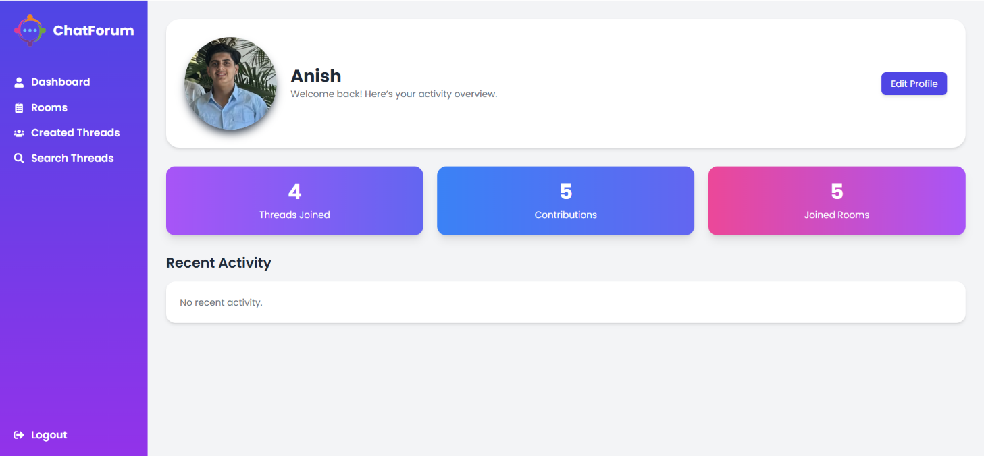
APPENDIX

Appendix A: Class Diagram of Chat Forum

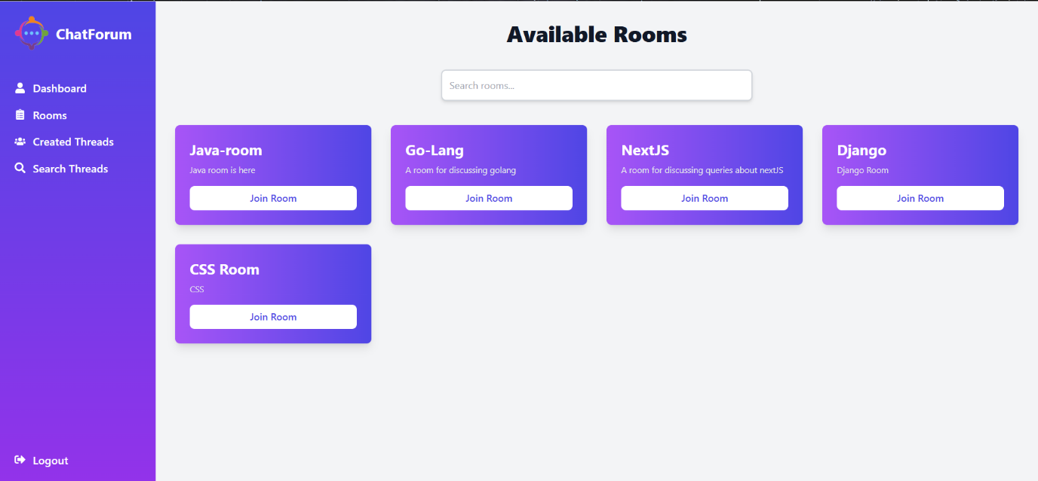

Appendix B: Room Page

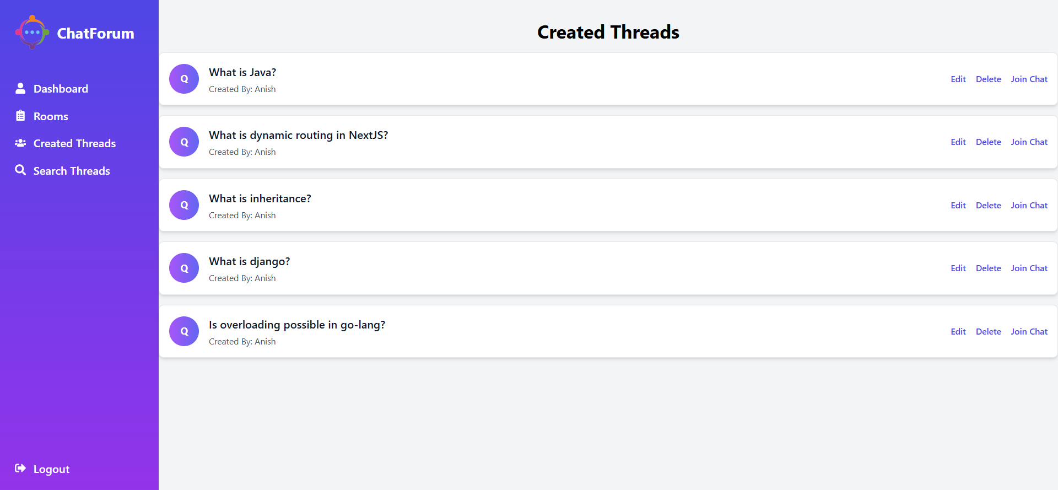
Appendix C: Created Threads Page

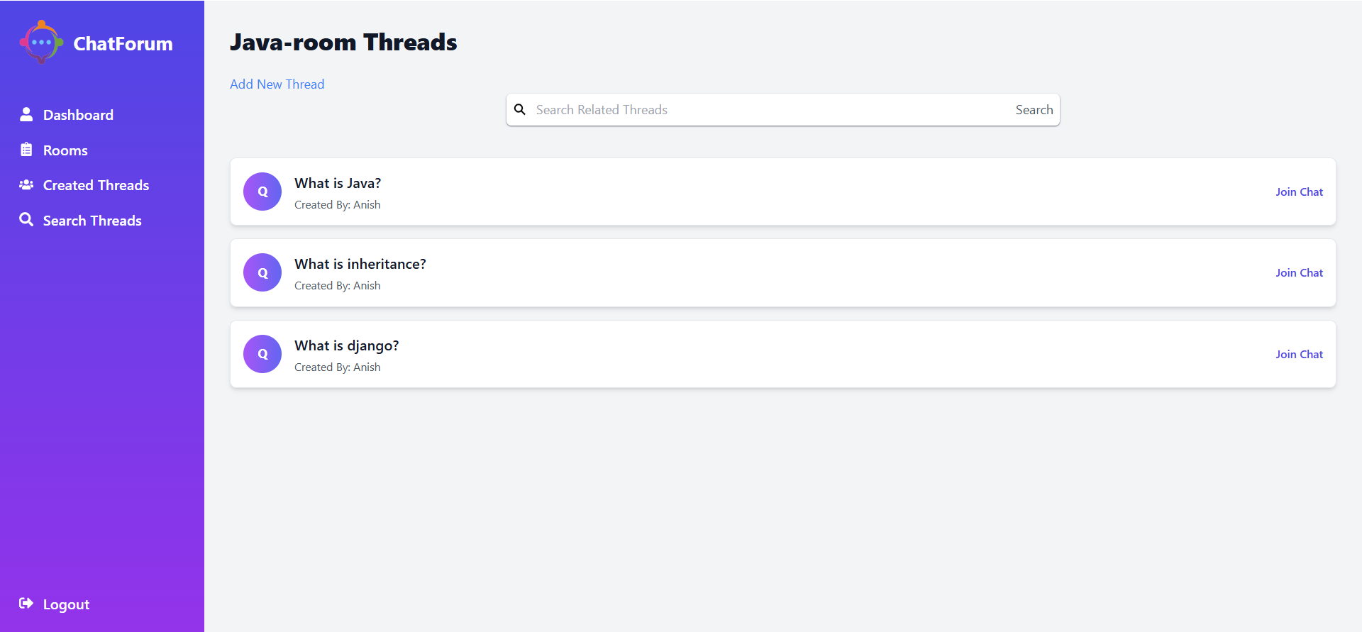
Appendix D: Threads page of a particular room

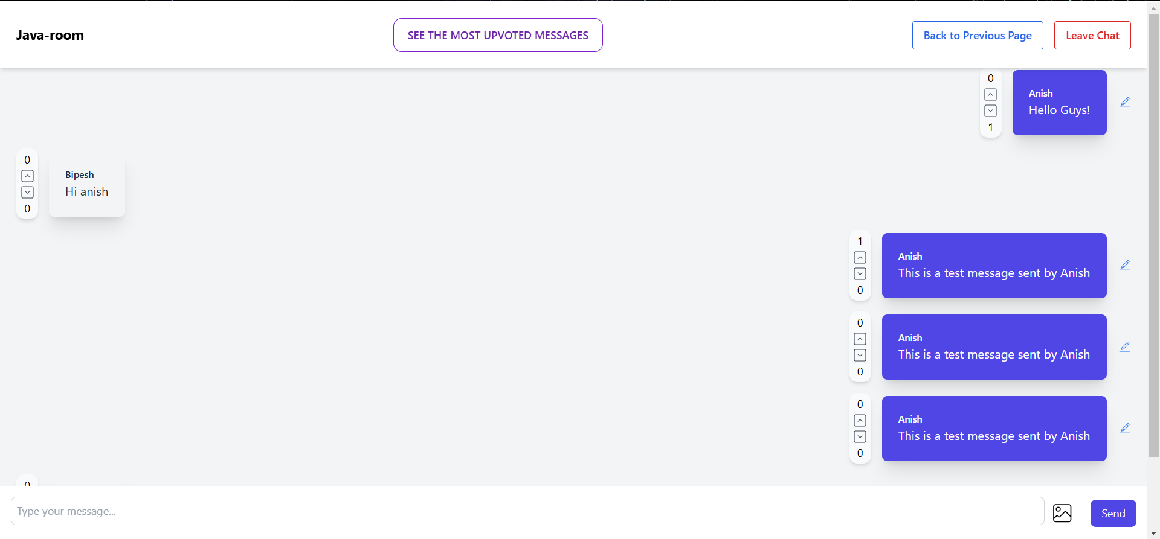
Appendix E: Chatroom of Java-room

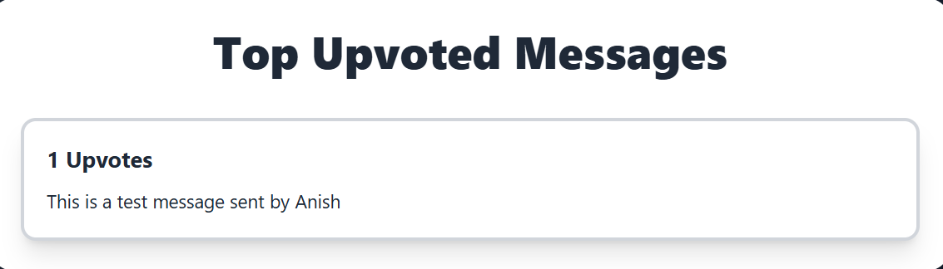
Appendix F: Most upvoted message of Java-room

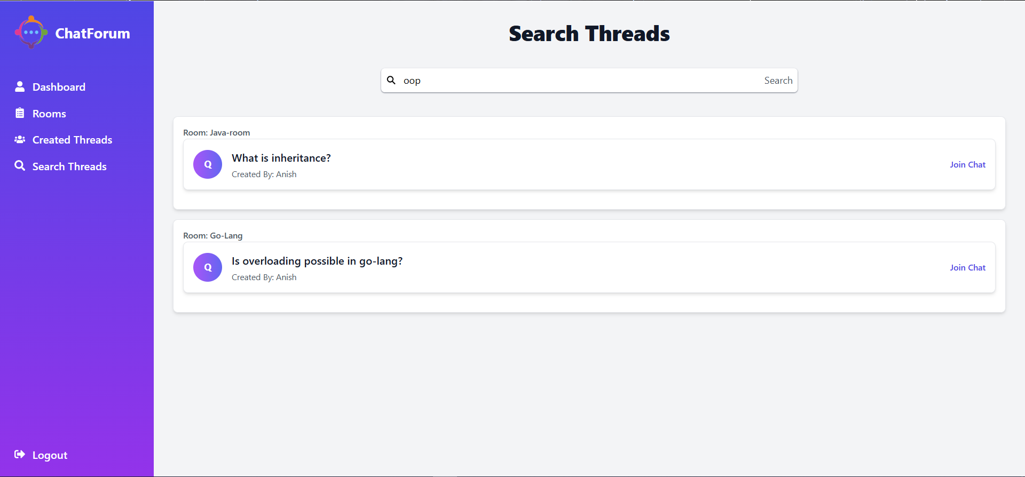
Appendix G: Threads Search Page

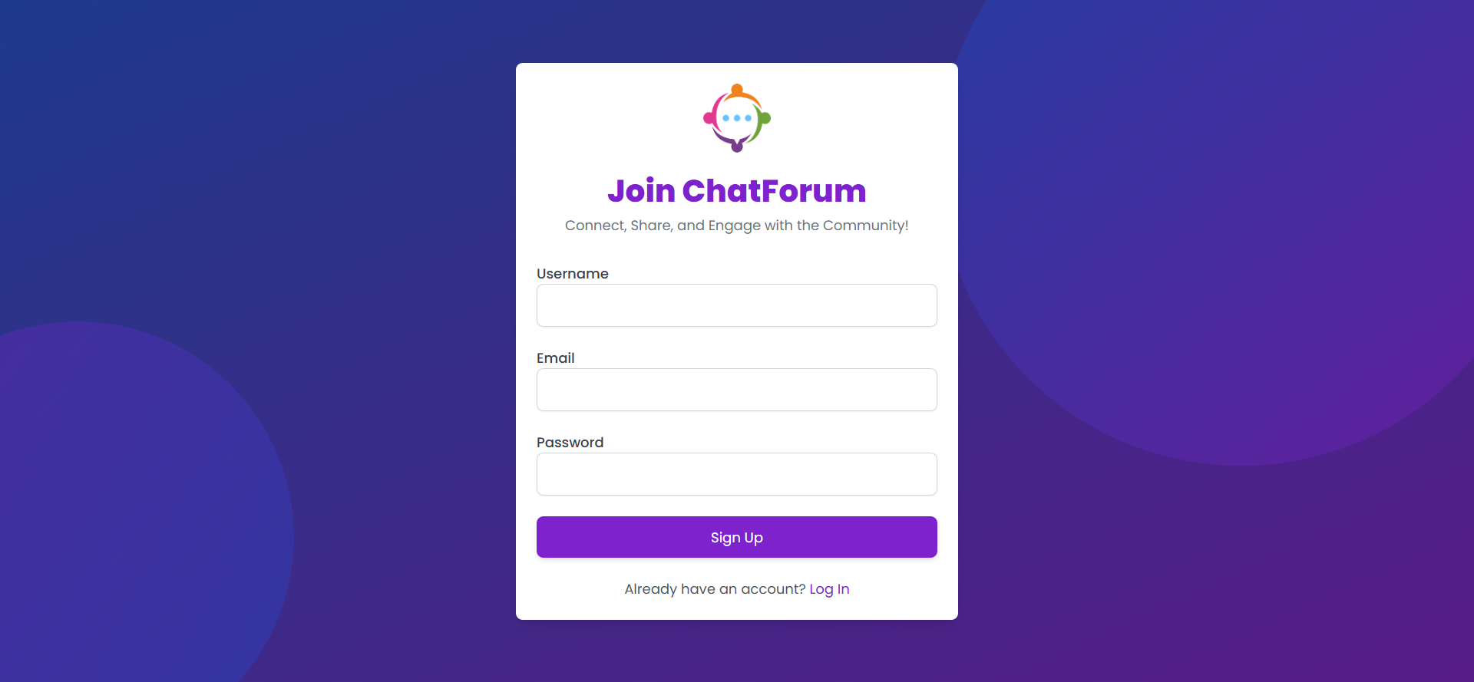
Appendix H: Register Page

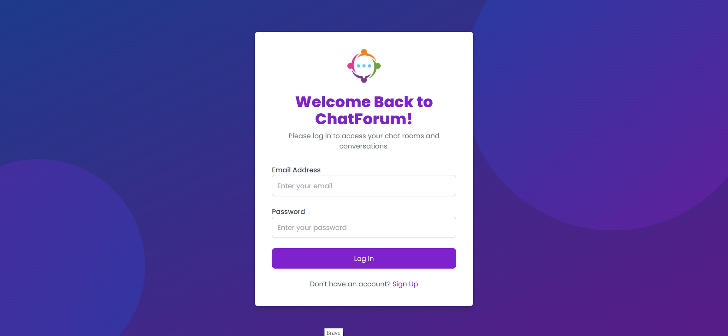
Appendix I: Login Page

